December 2023 monthly newsletter below:

Presidents Report
Dear Members

The last 6 months has definitely passed us by quickly with the festive season now upon us.
Our Christmas Party was a great success and it was lovely to see all the members and visitors enjoying the day and the fine spread of food.
I wish to thank all those volunteers who contributed their time and money to prepare for the day. An extra Big Thank you to Grant Maloney for his dedication to organising, cooking & catering, Sammy Rowe for the mowing, Wayne McMasters for donating and cooking his infamous green lip mussels, Robert Schembri for his honey smoked ham, Darren Nash for organising the prawns and to Santa.

Please join the committee this Wednesday Night from 7pm to celebrate the year with some Christmas drinks and a BBQ.

Look forward to seeing you all there.

Wishing you all and your families a Very Merry Christmas and a Happy & Safe New Year.
Petros Cozis
President
WPAC
Treasurers Report
The Xmas breakup Party and Junior presentation was a great success with more than enough food provided.
Great to see some of the new members attending with plenty of kids to enjoy the visit from Santa.
The membership has reached 76 including a total of 17 members affiliated with GFAV.
Entry forms are now available for the 2024 Whiting Challenge. See attached.
We are trying something new this year by using a QR Code to link direct to the On Line Entry page on our website as an option to Postal Entry and access via our website.
Over 70% of our entries were via On Line last year and this number continues to grow.
We have received another donation of pre loved fishing gear which has been added to the items left over from the November Secret Auction.
See attached list of Items remaining – reasonable offers will be considered or place a bid in the safe box.
Money raised from this Auction was used to help pay for the Xmas breakup Party hence we were able to keep the attendance fees down.
I hope everyone has a SAFE and Merry Xmas & Happy New Year.
Don Newman
Ph. 0400 194998

Weigh Masters Report
Hello all members we have had a couple of comps since the last meeting with some great results for people getting out and about on the fish in between the interesting weather patterns we have been receiving.
we have had the annual snapper comp wpac vs bsgfc which was well attended by both clubs with over 60 fish caught during the event unfortunately we missed out by 100 grams on the biggest fish so we are cooking the bbq next year again. Quick shout out the jnr ethan mcmasters representing the club with the heaviest fish to get within 100grams of the winner. A very big thank you to grant maloney for putting on the bbq as well as he does we all appreciate it , thanks shifty.

RESULTS :

24/11/23 CHAMPION ANGLER SNAPPER WPAC VS BSGFC
comp shield : bsgfc - clint adlington snapper 5.650kg
champion angler snr - Phil stroker 4/11.250kg
champion angler jnr - ethan mcmasters 3/10.950kg

9-10/12/23 Champion angler snapper weekend - We had some breaks in the weather over the course of the weekend , some people opted for port phillip others had a crack on westernport , the fishing has definitely changed with the smaller fish about now but in general the comp was slow for results across the board on larger fish.

champion angler snr - Patric Neidhart 8/ 8.400kg
champion angler jnr - Tane D 1/1.700kg
UPCOMING COMPS
sunday 7th of jan - champion angler kgw
sunday 28th of jan - champion angler kgw
sunday 11th of feb - champion angler kgw

thanks, everyone have a safe Christmas, hope you get a good break and catch lots of fish with friends and family
Pat wpac weighmaster.
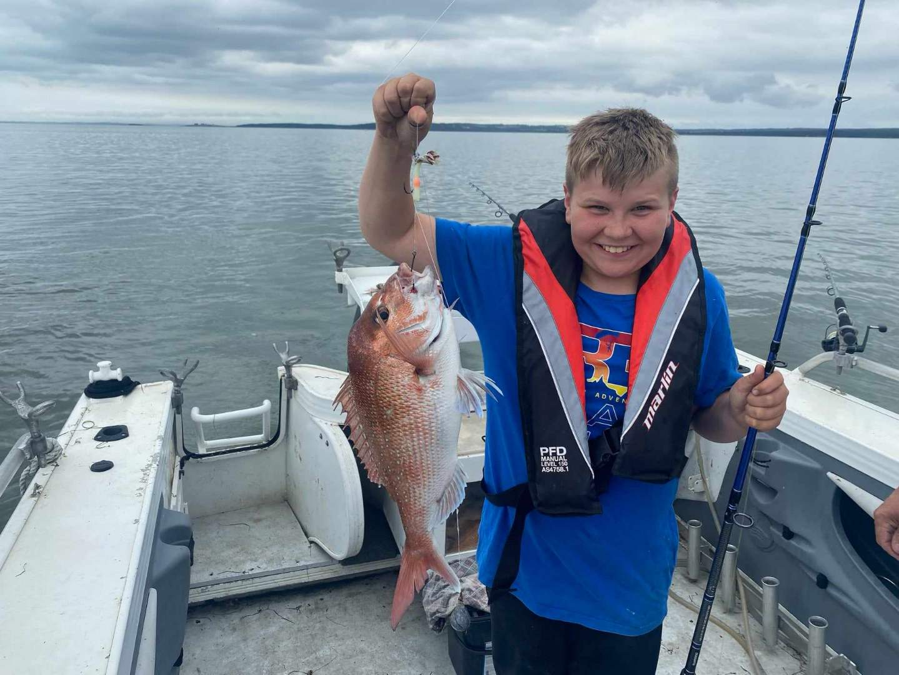

# | DESCRIPTION |  | # | DESCRIPTION
Yellow Highlight indicates ITEM SOLD |  |  | 44 | Vintage Ryobi AX123 Reel
1 | Jarvis Walker Game Rod |  | 45 | Plano box full of tackle
2 | Fenwick Game Rod |  | 46 | Jar of Assorted Sinkers
3 | Custom Snapper Rod |  | 47 | Tackleback Lure Retriever
4 | Silstar Rod |  | 48 | Assorted Fillet Knives & Fish Gripper
5 | Old Jarvis Walker Green Glass Rod |  | 49 | Surf Shoulder bag & Gimbal belt
6 | Jarvis Walker Flinders Rod |  | 50 | Hand Cast Spools & 30lb Mono Line
7 | Old Jarvis Walker Orange Glass Rod |  | 51 | Camping Hiking Kit
8 | Old Jarvis Walker Light Glass Rod |  | 52 | Hiking Backpack
9 | Yabby Pump |  | 53 | Hiking Backpack with seat
10 | Box Asst Hooks |  | 54 | Hiking Backpack Camo
11 | Box Asst lures |  | 55 | Hiking Folding Seat
12 | Small box Asst Hooks |  | 56 | Vintage Alvey 450 A3 Rosewood Sidecast Reel
13 | Plano Box incl Plastics |  | 57 | Vintage Mitchell Spin Reel Collection (X 8)
14 | Chuyo OH Reel |  | 58 | Gillies Folding Landing Net
15 | Seascape OH Reel - Vintage Australian |  | 59 | Tackle Box with Telescopic Rod & Reel
16 | Plano Box incl Tackle |  | 60 | Toy Telescopic Rod Reel (X2)
17 | Aluminium Live Bait Tank incl Fittings |  | 61 | Telescopic Rods Assorted (X 5)
18 | Box Tools, Line, Scaler Bag |  | 62 | Dam Quick Spin Reel in Box
19 | Flounder light |  | 63 | Shakespeare Tidewater Spin Reel in Box
20 | SS Anchor Danforth Small |  | 64 | Wall Mount Rod Rack
21 | SS Anchor Danforth Large |  | 65 | Tackle Pouch Belt
22 | SS Anchor Folding |  | 66 | Assorted LED Torches (X 2)
23 | SS Anchor Grapnel |  | 67 | Assorted Multi Tools (X 3)
24 | Shakespere Snapper Combo |  | 68 | Gerber Pocket Knife
25 | Shakespere Jig Combo |  | 69 | Assorted Fillet Knives, Glove, Stone & Steel
26 | Shakespere Jig Combo |  | 70 | Split Ring Pliers (X 2)
27 | Humminbird Pirahna 175 Portable |  | 71 | Lanyard Tool Kits (X 2)
28 | Humminbird PirahnaMax 4 DI |  | 72 | Electronic Bite Indicator
29 | Silstar Knife Set |  | 73 | Blue Padded Rod Bags (X 3)
30 | Mustad Inkvader Lure |  | 74 | Mini Tackle Kit Boxes Yellow (X 2)
31 | Lure Mate Lure Tidy |  | 75 | Small Tackle Tray with Sinkers etc.
32 | Samurai Hand Pocket Towel X2 |  | 76 | Assorted Lures & Swivel Kits
33 | Winch Handle |  | 77 | Opera House Bait Net
34 | Box of Squid Jigs |  | 78 | Fly Rod Reel Combo Shakespeare
35 | Tackle Trays X2 |  | 79 | Blue Hornet Plug Caster Rod Reel Combo
36 | 10ft Butterworth Surf Rod Alvey Reel |  | 80 | Assorted Spin Rod Reel Combos (X 3)
37 | 8ft Surf Rod & Alvey Reel |  | 81 | Daiwa Surf Rod in Bag
38 | 8ft Penn Defiance Snapper Rod & Reel |  | 82 | Daiwa Bait Caster Combo LH Wind
39 | Gary Howard Baitcast rod & ABU Reel |  | 83 | Vintage Fishing Books (X 4)
40 | Original JW Black Queen Rod |  | 84 | Vintage Solid Glass Rod
41 | Alvey Model 600B Sidecast Reel |  | 85 | Assorted Fishing Line Spools
42 | Alvey Fibreglass 500C Sidecast Reel |  | 86 | Vintage Zebco Plug Caster Reel
43 | Vintage Shimano Spin Reels X2 |  | 87 | Jarvis Walker Ruffy Spin Rod

